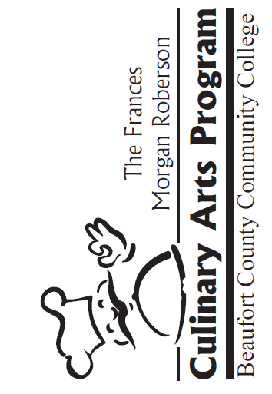Beaufort County Community College

5337 US Hwy 264 East Washington, NC 27889

252-946-6194

**Foundation Scholarship Application**

One (1) scholarship will be awarded per class. The scholarship will cover the registration, supply, and insurance fees. Any additional items purchased by a student will be at the student’s expense. The student will also be responsible for all fees associated with the Exploring Culinary Arts pre-requisite class.

The scholarship will be awarded prior to the beginning of class and funds credited directly to the student’s account by the Business Office. The student will not receive a check for these funds.

The student must attach a copy of their signature page from their most recent tax return to demonstrate financial need. Prior to the release of scholarship funds to the student’s account, the student is required to visit the BCCC Foundation office, Building 1, Room 113 to have their photo taken, sign a press release, and write a thank you note to the scholarship donor.

Applications should be turned in at least two weeks prior to the start of classes. Late applications will not be considered.

Please make sure all information is complete. Incomplete applications will not be considered*.*

Student Name:

Street Address:

City, State, Zip:

Phone Number: County of Residence:

Email:

* Please provide an email account that you check frequently as well as a phone number that has voice mail.

Please explain, in your own words, why you should receive the Frances Morgan Roberson Scholarship.

I hereby verify that all information given is complete and accurate to the best of my knowledge.

Printed Name of Student

Student Signature Date

*Please submit your completed application to:*

Director of Workforce Initiatives

[continuing.education@beaufortccc.edu](mailto:continuing.education@beaufortccc.edu?subject=ATTN:%20Director%20of%20Workforce%20Initiatives)

Direct Number: 252-940-6307